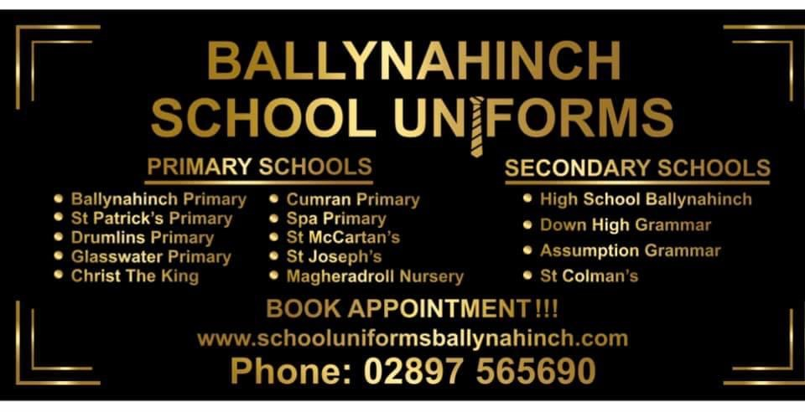

PLEASE NOTE WE HAVE MOVED TO
29 High Street | Ballynahinch | BT24 8AB
(PREVIOUSLY DANSKE BANK)

T: 028 97565690.
!ONLINE UNFORM SHOP COMING SOON!

School Uniforms – System

E: uniforms@schooluniformsballynahinch.com

Dear Parent/Guardian

Due to the success of our newly introduced system last year, we are delighted to continue using the same system this year. We have taken all Government guidelines on board and have put safe and secure measurements in place so that children and parents can come into the store knowing it is safe to do so.

We will be running an appointment system which can be booked either on-line on the uniform website (https://schooluniformsballynahinch.com). We will allow 30 minute appointments per child. Please ensure that if you have more than one child you book more than one appointment. We would ask if parents could take into account the uniform sizes their children are wearing at present so we can have appropriate sizes ready for when children come into the store looking for new sizes of uniforms e.g. if a child is currently wearing size 32, they may require 34 or 36.

For any Secondary Schools, Pay £50 Deposit per child by the 30th June 2021 to secure your 20% OFF to use in July and August 2021 https://schooluniformsballynahinch.com

For any Primary Schools we will be offering 10% off Uniforms in July and August 2021(

We will be continuing with our Uniform School Payment Club https://schooluniformsballynahinch.com

OPENING TIMES
Monday, Tuesday, Friday and Saturday we will be open 9.30am- 5.30pm.
Wednesday night we will be providing a “Quiet Night” until 8pm.
Thursday Late night opening 9.30am – 8pm.

I look forward to welcoming you to our new School Uniform premises.

Kind regards,

Eamon McAuley

