ST JOSEPH’S PRIMARY SCHOOL
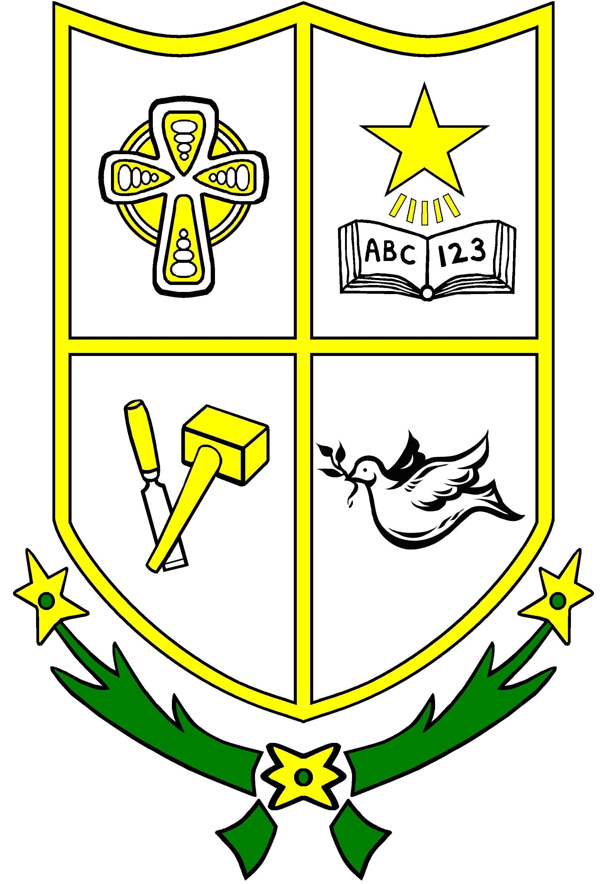
Tel No: 02844 830810 4 Ballynahinch Road
 Fax 02844 831961 Crossgar
Principal: Mrs S McArdle BT30 9HS

Dear Parents,

Free School Meals/School Uniform/Physical Education Clothing Allowance 2021-22

I would like to provide you with an update on the 2021/22 application process for Free School Meals and School Uniform/ Physcial Education Clothing Allowances.

The Education Authority (EA) will be issuing communications on the EA website and social media channels to inform parents/ guardians to awareness of Free School Meals and Clothing Allowances, and to encourage all potential applicants to apply for the support available.

Current Eligible Families and New Applicants
Parents/guardians who are currently in receipt of support for the 2020/21 school year will not be sent a pre-populated form for the 2021/22 school year. All parents/ guardians (including new applicants) are required to apply on-line from Monday, 7 June 2021 via the EA website https://www.eani.org.uk/financial-help/free-school-meals.
It is recommended that parents/ guardians apply during the month of June, or as early as possible, to enable applications to be processed for support to be in place for their children for the new school year. Parents/ guardians are being advised of the importance of providing valid Bank or Building Society account details in the claimant’s own name. Payments cannot be made into Post Office accounts.

Special Diet
Parents/Guardians whose child has a Statement of Special Educational Needs (Stage 5) and requires a special diet should contact the Meals and Uniform Section for a paper application form if they wish to apply under the special diet criteria.
Free School Meals / Uniform Grants Helpdesk
The Free Schools Meals and Uniform Grants Helpdesk is operated by staff across the EA Free School Meals/ Uniform Grants service.
It is available to assist parents/guardians and schools who may have any queries. The Helpdesk operates Monday – Friday from 9.00am to 4.30pm and can be contacted via email: mealsanduniform@eani.org.uk. The telephone number which should be used for all enquiries is: (028) 9041 8044.

E-mails and telephone calls should no longer be made directly to individual Free School Meals/ Uniform staff as they will be diverted to the Helpdesk for response.
Further information including eligibility criteria for the 2021-22 school year and a list of Frequently Asked Questions to assist with any parental queries can be accessed by logging onto www.eani.org.uk/financial-help/free-school-meals.

It is important that you apply soon and contact EA if you need any support with your application using the recommended contact details above.

Yours Sincerely,

S McArdle
Principal

