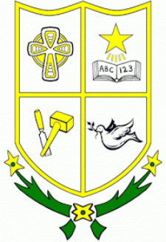
ST Joseph’s PTA Charity
Newsletter 2021

Dear Parents,
With so much happening in the world today and with the Covid-19 pandemic our children’s school community need our support. Over that last few years, the PTA have been working behind the scenes on improving events to bring more positive experiences to the students within St Joseph’s. The PTA have decided to hold both free events and fundraising events this year. We value all your generosity, kindness and support. By working together as a school community, we can ensure that all our children get the best opportunity and experience within St Joseph’s Primary.

What is the PTA?
The Parent Teacher Association (PTA) is parents and the school working and fundraising together to make a positive difference to the school experience of all the pupils attending St Joseph’s Primary School.

What does the PTA do?
The PTA organises events and activities throughout the school year. St Joseph’s PTA is a registered Charity that adheres to the charity commission N.I.
Events:
- School Disco
- Bingo
- Raffles
- Jumble Sales
- Bake Sale
- Tuck Shop
- Class Parties
Plus, much more.
Getting Involved:
If you would like to make a positive difference in your child/children’s primary school experience why not volunteer your time and get involved in the PTA. Everyone is welcome, however much or little time you have to spare we can all make a difference working together towards a happy and successful school experience.
The PTA are dedicated to improving the overall school experience through promoting education, health and wellbeing.

Funding and Donations:
The PTA make generous donations to St Joseph’s Primary School each year. For this school year 2020/2021 PTA have funded:
- New school I Pads
- Front & Back Playground Equipment
- Reading Eggs
- School Resources
- Selection Boxes

Upcoming Events
- Virtual Pancake Day: 23rd February
- Raffle: TBC

Donation Links
Amazon Smile:
https://smile.amazon.co.uk/ch/104229-0
PayPal: TBC

Yours sincerely,
St Joseph’s PS Charity
PTA

