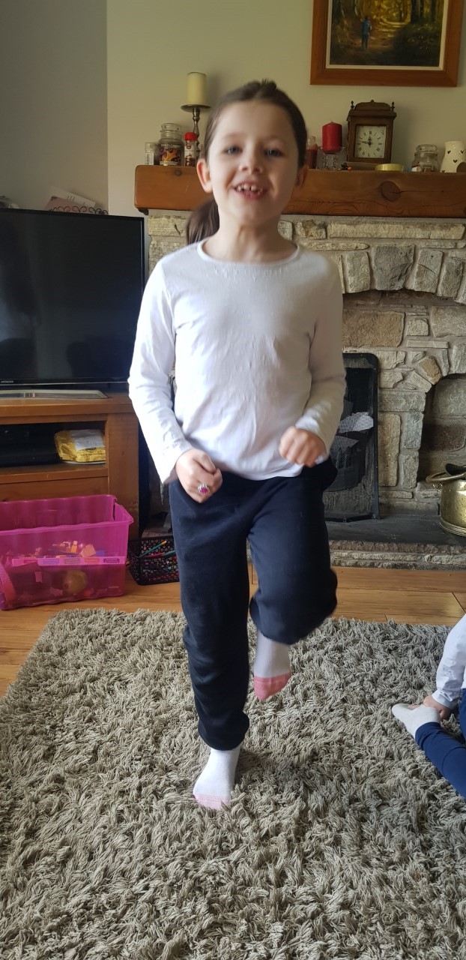
Jogging on the spot:

- Jog on the spot for 1 minute

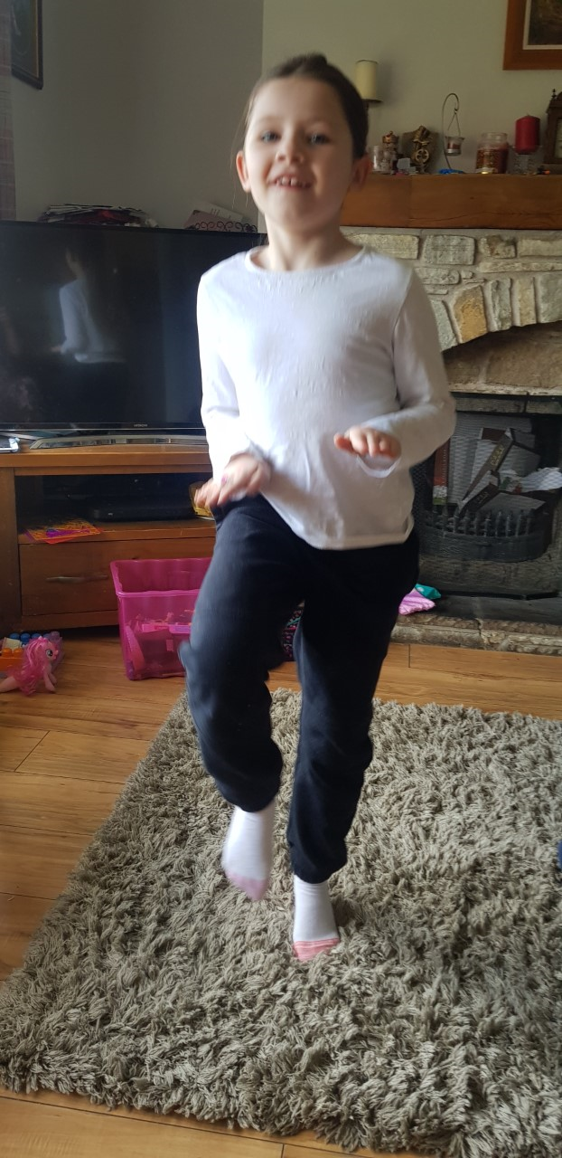
High knees:
- Put hands out in front of body (about waist height)
- try to lift your knees high to touch your hands.
- Continue for 1 minute.

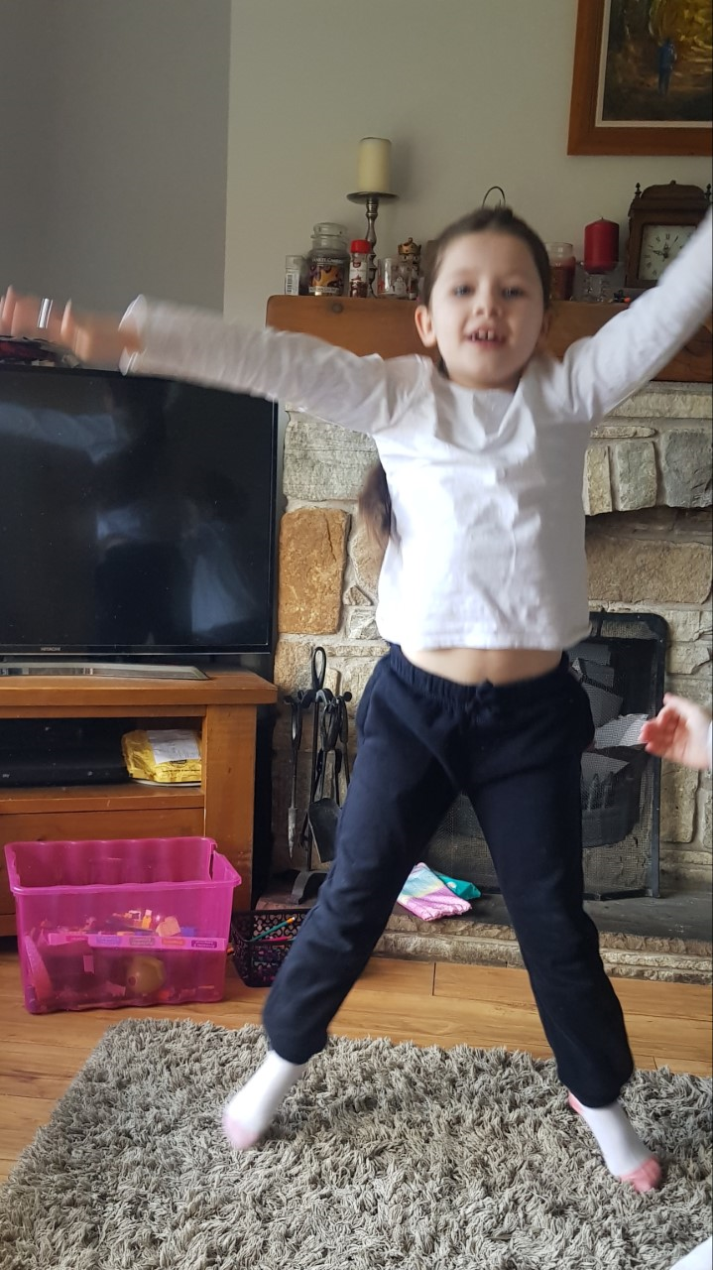
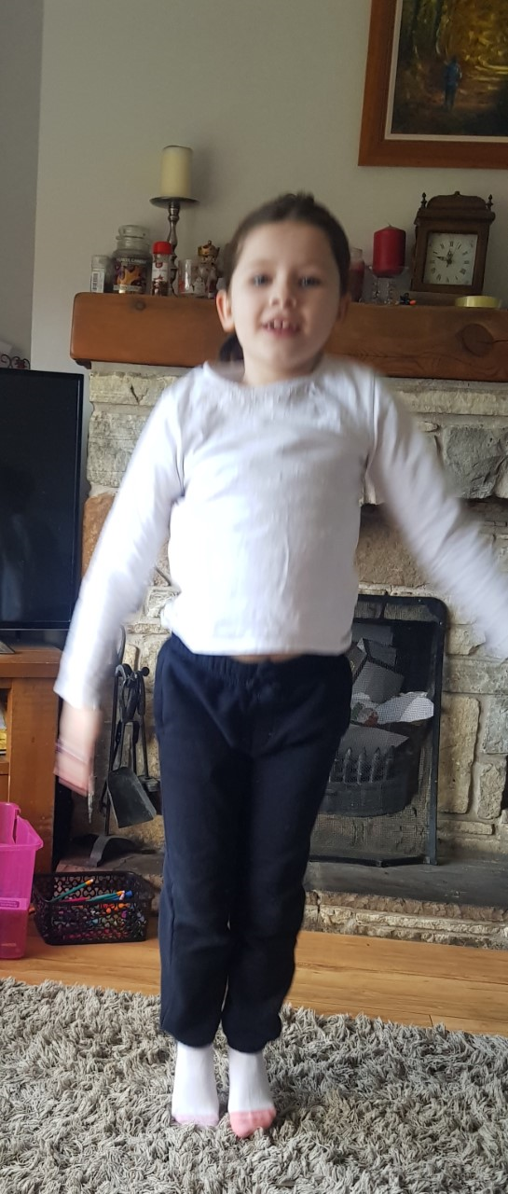
Star jumps
- Start at standing position
- Jump whilst moving arms and legs outwards to resemble a star.
- Repeat for 1 minute
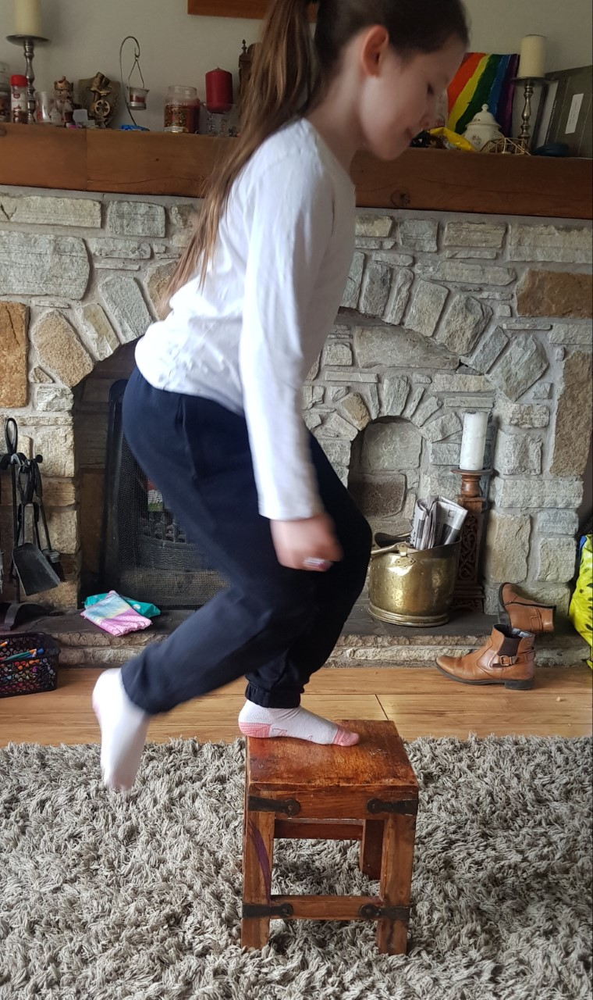
Step-ups
Using a small stool or step, step-up and down for 1 minute.

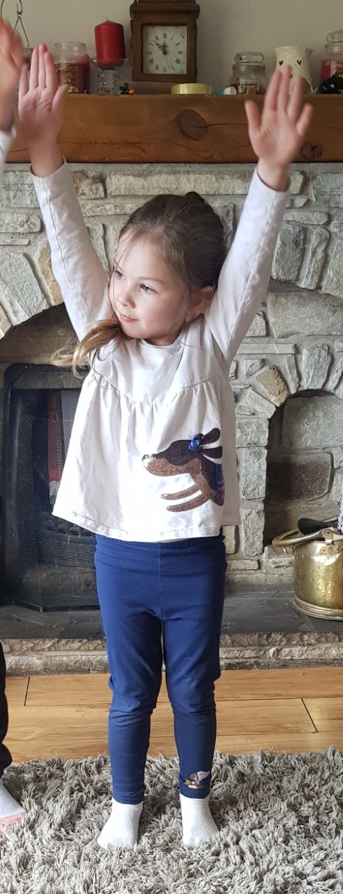
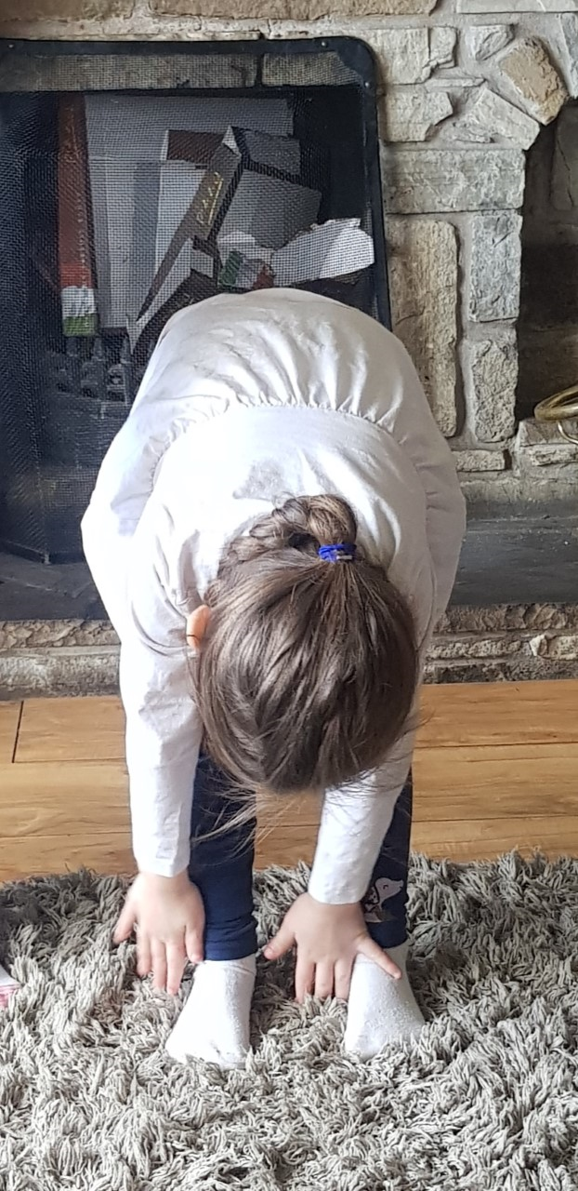
Toe-touches
- Start in a standing position
- Raise hands in the air
- Bend down to touch your toes
- Repeat for 1 minute.

Row the boat
- Get a partner
- Sit on the floor facing each other with feet touching
- Hold hands and move forwards and backwards like you are rowing a boat.
- Continue for 1 minute.
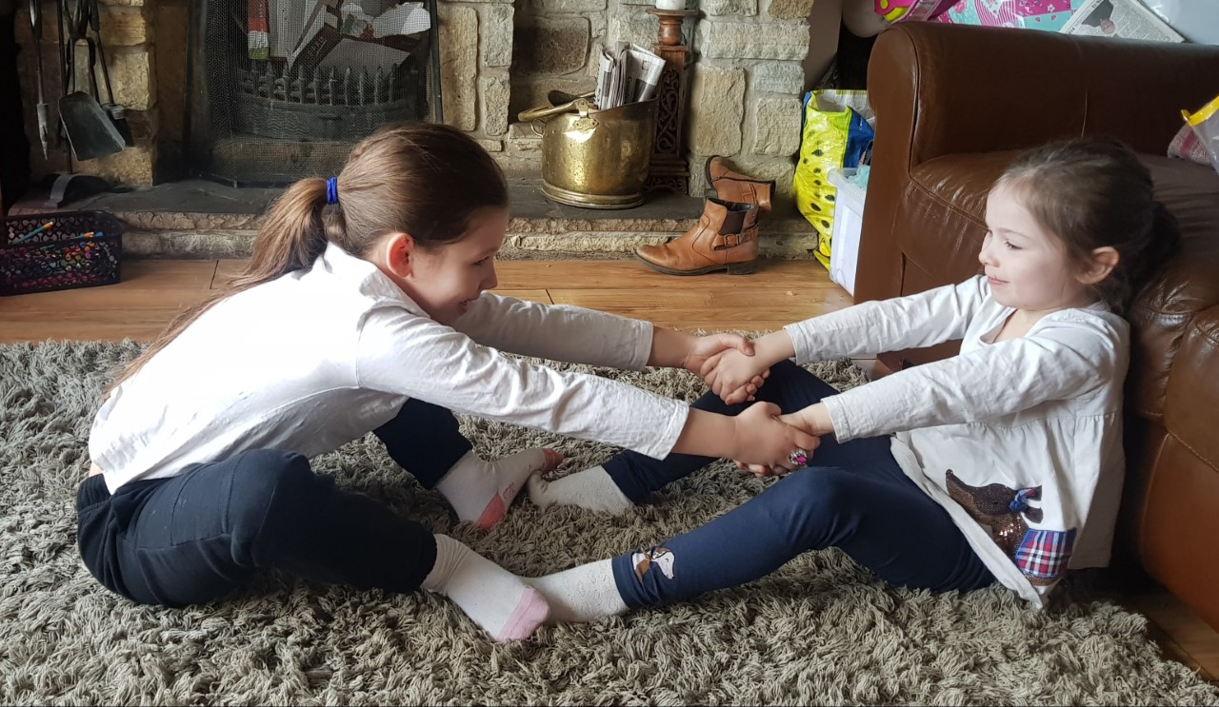

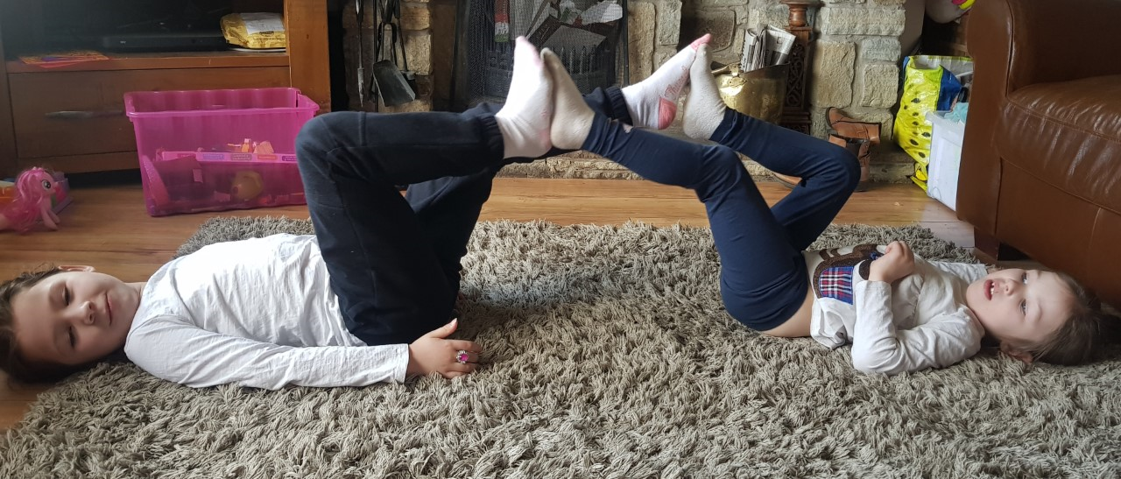
Tandem bicycle
- Get a partner
- Lie opposite your partner
- Move your legs in a circular pattern
- Continue for 1 minute

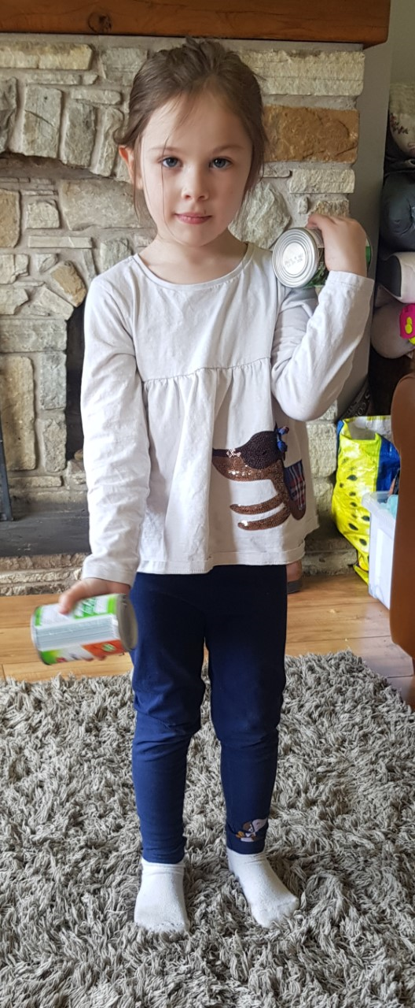
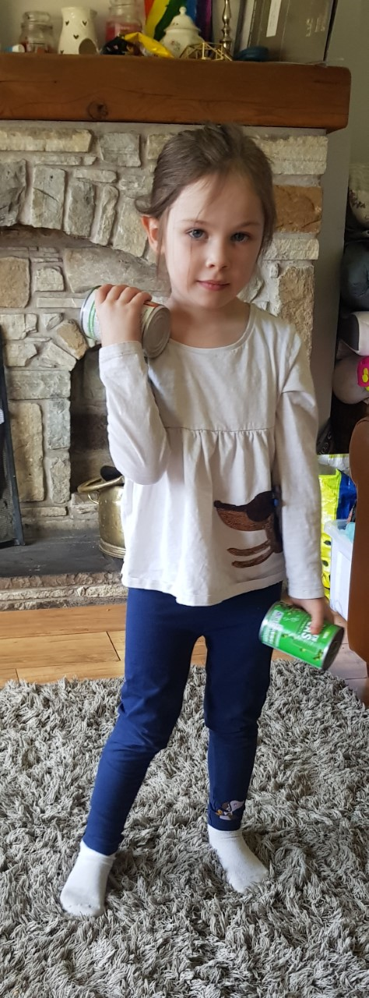
Bicep curls

- Get something to curl (e.g cans)
- Move your arms up and down
- Continue for 2 minutes

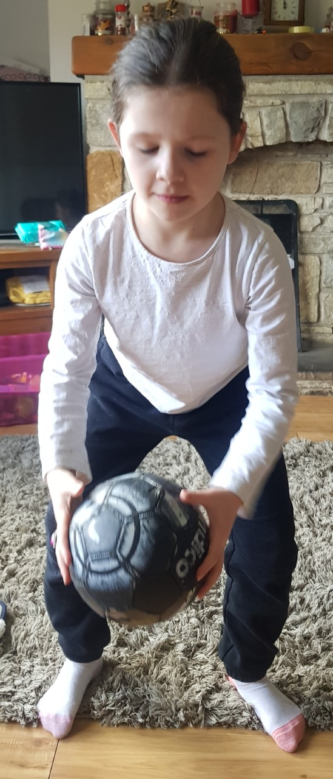
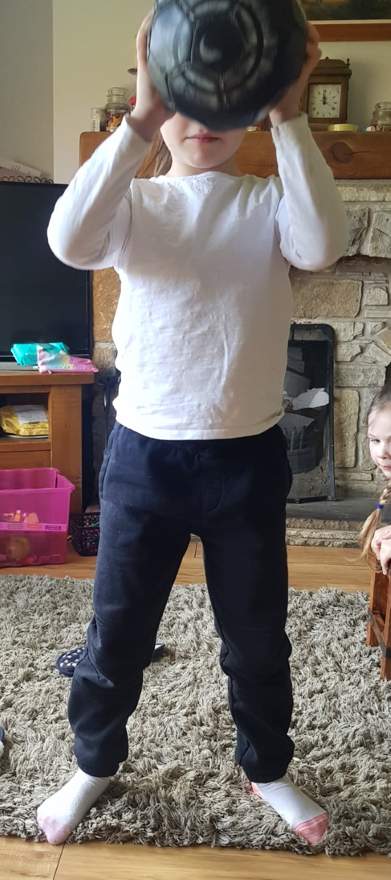
Ball bounces

- Bounce the ball continuously for one minute

