ST JOSEPH’S PRIMARY SCHOOL
EASTER DRAW
2026

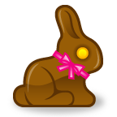
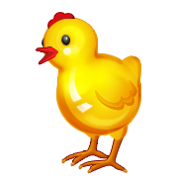

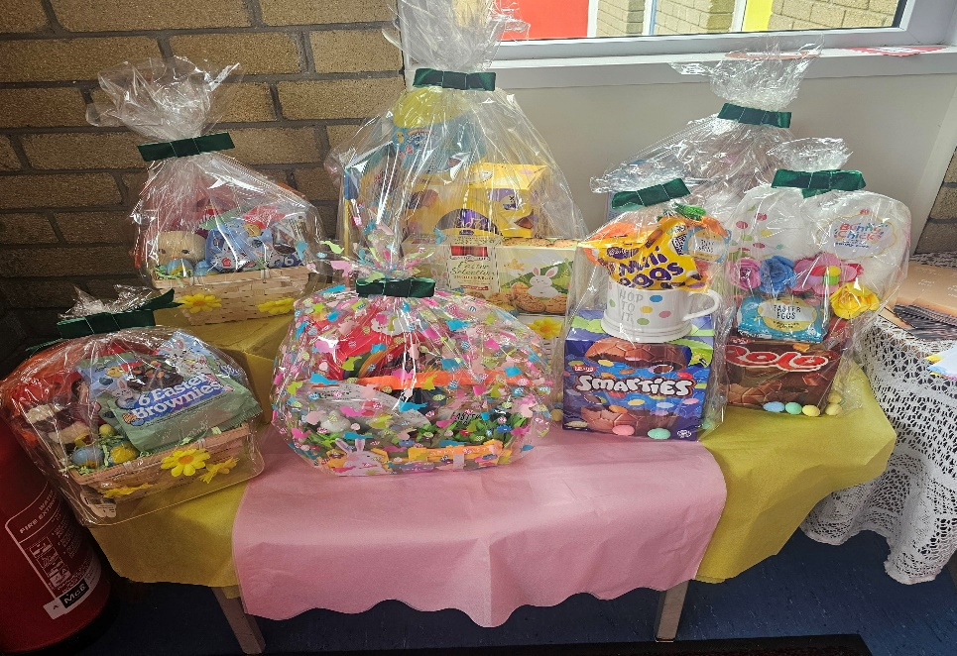

A list of 6 prizes to be won!

1st Prize Grand Easter Egg Hamper
2nd Prize Rabbit Teddy Hamper and treats.
3rd Prize 2x Garden baskets with eggs / treats
4th Prize Head band, Easter egg and Treats
5th Prize Smarties Easter Egg with Cup.
6th Prize Skittles Egg Fun Basket / DIY Bunny Paint

Draw will take place in the school on Wednesday 1st April 26
Tickets £1.00 each or £5 book of 6.

