P7 Presents:
‘Christmas Story ‘Kilmore Rec Style’
Friday 17th December
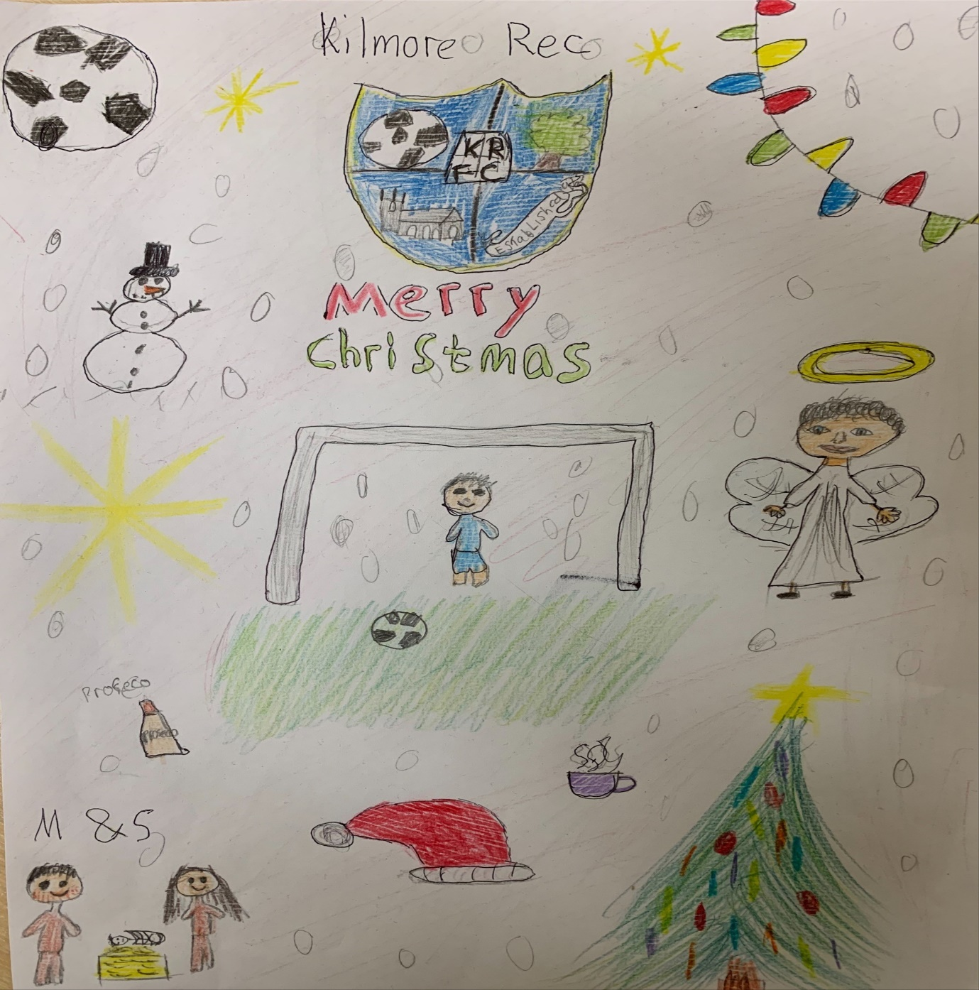

Programme picture by Holly Tipper

Our cast:

Mary Lily Curran
Joe Lewis Kennedy
Gabriel Sean Mullan
Manager/John Corey Byrne-Braiden
Mum Shannon Canavan
Dad/Gaz Alexander Pachocki
Beccy Aoibheann Carville-Maskey
Emily Caitlin Mc Menamin
Gillian Holly Tipper

Paula Olivia Campbell
Bill Kai Dougan
Ruby Orlaith Gill
Janet Sarah Marks
Carole Caoimhe Russell
Mel Oliver Quinn
Baz Ryan Hamilton
Kilmore diehard Oisin McKendry

Front of house: Kai Dougan and Caoimhe Russell
Close of house: Orlaith Gill and Oisin McKendry

We wish you all a very happy Christmas and a happy new year

