ANTARCTICA

What is Antarctica?

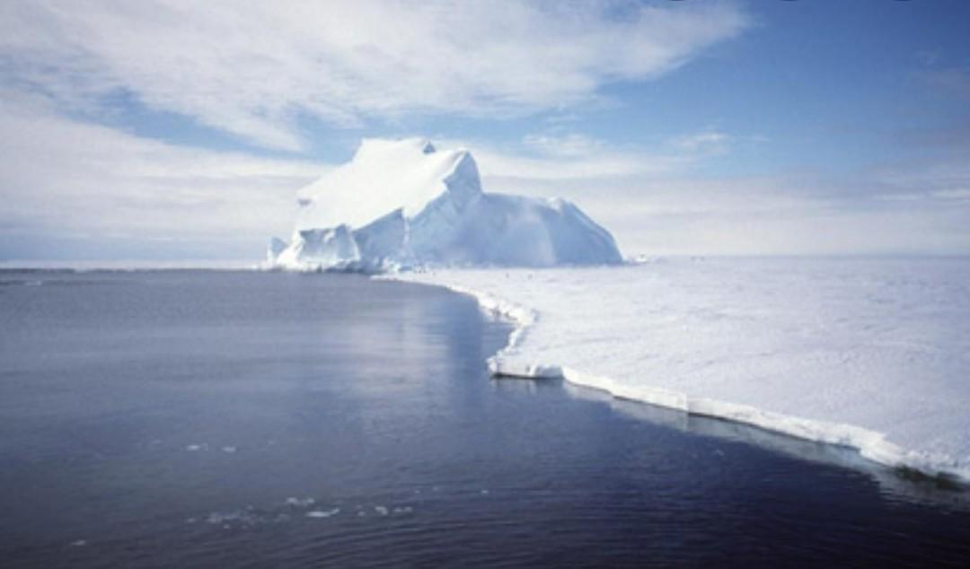

Antarctica is a continent. It is the earth's fifth largest continent. It is mostly covered in ice and covers the Earth's South Pole.

Antarctica is the coldest place on Earth. In winter, the temperature is so low that the water freezes all the time. The temperature in the middle of Antarctica is much colder than the coast.

There are two seasons in Antarctica, summer and winter. It is sunny in the summer and dark in the winter.

It is too cold for people to live there for along time. Tourists visit Antarctica in the summer. Whales live in the oceans surrounding Antarctica. It is the home to seals and penguins.

