

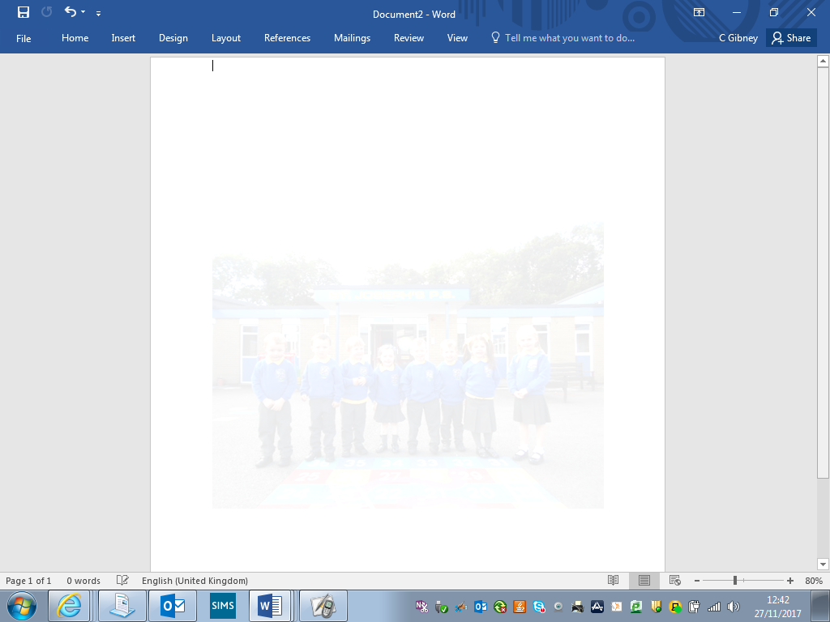

**St Joseph’s Primary School Crossgar**

**“Learn to love, love to learn”**

**Due to covid restrictions unfortunately we are unable to host an open day.**

**View the virtual tour of our school on our school website (available week beginning 7th December 2020).**

[**www.stjosephsps.org.uk**](http://www.stjosephsps.org.uk)

**Join Mrs McArdle (Principal) on a zoom call to find out more about our school.**

**Time: Dec 10, 2020 03:30**

**Contact the school for details on joining.**

**We look forward to welcoming you to St Joseph’s. If you have any questions, please do not hesitate to call us on 02844830810.**

**Follow us on Facebook**

**www.facebook.com/stjosephscrossgar**